**Clase 1 admin db avanzado**

02/08/2017

Profesor: Andrés Martínez

Mail: [andresmartinez2656@correo.itm.edu.co](mailto:andresmartinez2656@correo.itm.edu.co)

**Contenido**

* Control versión systematic (git-github)
* Normalización
* DBMS
* Logical vs physical design
* Dba, roles, profiles, adminstration
* Indexes- views
* Error handling
* Tablespace, datafile
* Remote database (AWS)
* ETL
* monitoring
* Backup restores
* PL/SQL cursors
* Store procedures
* transactions, race conditions, concurrency
* good practices
* licensing
* NoSQL database (Firebase)

**Important Dates**

* Teacher evaluation
  + Sept 4 - sept 9
  + Oct 17 - Oct 21
* 60% SIA = Oct 14
* 100% SIA= Nov 27
* Final
  + 22 - 27 nov

**Clase 3 09/08/2017**

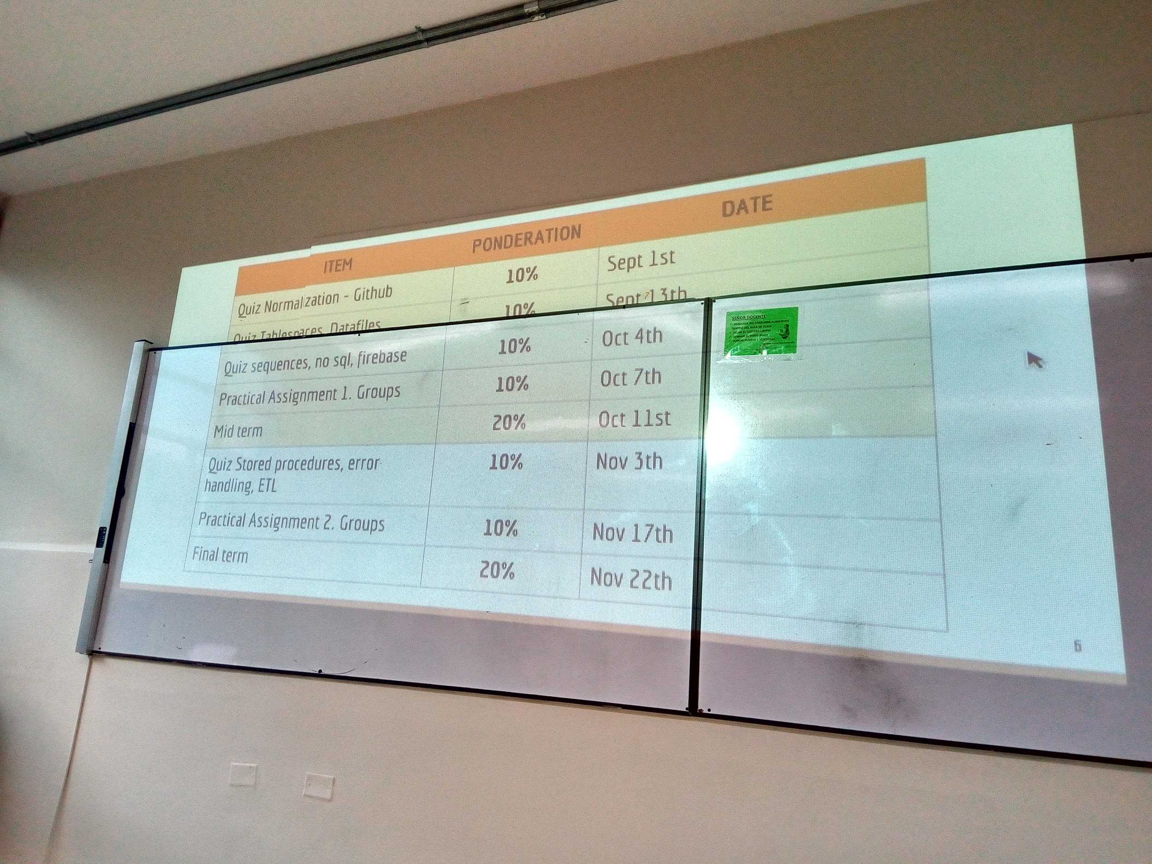

Clase 4 -- 11/08/2017

salak406@salak406-5 MINGW64 ~

$ cd ..

salak406@salak406-5 MINGW64 /c/Users

$ cd ..

salak406@salak406-5 MINGW64 /c

$ cd Clase

salak406@salak406-5 MINGW64 /c/Clase (Nueva_Rama)

$ git status

On branch Nueva_Rama

Untracked files:

(use "git add <file>..." to include in what will be committed)

bd.txt

cd

git

nothing added to commit but untracked files present (use "git add" to track)

salak406@salak406-5 MINGW64 /c/Clase (Nueva_Rama)

$ git init

Reinitialized existing Git repository in C:/Clase/.git/

salak406@salak406-5 MINGW64 /c/Clase (Nueva_Rama)

$ git add bd.txt

salak406@salak406-5 MINGW64 /c/Clase (Nueva_Rama)

$ git status

On branch Nueva_Rama

Changes to be committed:

(use "git reset HEAD <file>..." to unstage)

new file: bd.txt

Untracked files:

(use "git add <file>..." to include in what will be committed)

cd

git

salak406@salak406-5 MINGW64 /c/Clase (Nueva_Rama)

$ git status

On branch Nueva_Rama

Changes to be committed:

(use "git reset HEAD <file>..." to unstage)

new file: bd.txt

Changes not staged for commit:

(use "git add <file>..." to update what will be committed)

(use "git checkout -- <file>..." to discard changes in working directory)

modified: Prueba.txt

Untracked files:

(use "git add <file>..." to include in what will be committed)

cd

git

salak406@salak406-5 MINGW64 /c/Clase (Nueva_Rama)

$ git add Prueba.txt

salak406@salak406-5 MINGW64 /c/Clase (Nueva_Rama)

$ git status

On branch Nueva_Rama

Changes to be committed:

(use "git reset HEAD <file>..." to unstage)

modified: Prueba.txt

new file: bd.txt

Untracked files:

(use "git add <file>..." to include in what will be committed)

cd

git

salak406@salak406-5 MINGW64 /c/Clase (Nueva_Rama)

$ git commit -m "commit en nueva rama"

[Nueva_Rama 56f6751] commit en nueva rama

Committer: Sala K406 <salak406@itmsalas.edu.co>

Your name and email address were configured automatically based

on your username and hostname. Please check that they are accurate.

You can suppress this message by setting them explicitly:

git config --global user.name "Your Name"

git config --global user.email you@example.com

After doing this, you may fix the identity used for this commit with:

git commit --amend --reset-author

2 files changed, 35 insertions(+)

create mode 100644 bd.txt

salak406@salak406-5 MINGW64 /c/Clase (Nueva_Rama)

$ git log

commit 56f67517f238fef119eb1f242670390cfdbd8ed5

Author: Sala K406 <salak406@itmsalas.edu.co>

Date: Fri Aug 11 06:49:57 2017 -0500

commit en nueva rama

commit f3fb6c1bb49cd81d50c9ec6ad4876b9cc46fbf4b

Author: Sala K406 <salak406@itmsalas.edu.co>

Date: Fri Aug 11 06:41:29 2017 -0500

commit inicial

salak406@salak406-5 MINGW64 /c/Clase (Nueva_Rama)

$ git status

On branch Nueva_Rama

Untracked files:

(use "git add <file>..." to include in what will be committed)

cd

git

nothing added to commit but untracked files present (use "git add" to track)

salak406@salak406-5 MINGW64 /c/Clase (Nueva_Rama)

$ git add .

salak406@salak406-5 MINGW64 /c/Clase (Nueva_Rama)

$ git commit -m "commit en nueva rama w312"

[Nueva_Rama 17c95c9] commit en nueva rama w312

Committer: Sala K406 <salak406@itmsalas.edu.co>

Your name and email address were configured automatically based

on your username and hostname. Please check that they are accurate.

You can suppress this message by setting them explicitly:

git config --global user.name "Your Name"

git config --global user.email you@example.com

After doing this, you may fix the identity used for this commit with:

git commit --amend --reset-author

2 files changed, 0 insertions(+), 0 deletions(-)

create mode 100644 cd

create mode 100644 git

salak406@salak406-5 MINGW64 /c/Clase (Nueva_Rama)

$ git status

On branch Nueva_Rama

nothing to commit, working tree clean

salak406@salak406-5 MINGW64 /c/Clase (Nueva_Rama)

$ git log

commit 17c95c9001d1f671d90ac1310f37ce0a7d6a786d

Author: Sala K406 <salak406@itmsalas.edu.co>

Date: Fri Aug 11 06:50:57 2017 -0500

commit en nueva rama w312

commit 56f67517f238fef119eb1f242670390cfdbd8ed5

Author: Sala K406 <salak406@itmsalas.edu.co>

Date: Fri Aug 11 06:49:57 2017 -0500

commit en nueva rama

commit f3fb6c1bb49cd81d50c9ec6ad4876b9cc46fbf4b

Author: Sala K406 <salak406@itmsalas.edu.co>

Date: Fri Aug 11 06:41:29 2017 -0500

commit inicial

salak406@salak406-5 MINGW64 /c/Clase (Nueva_Rama)

$ touch prueba2.txt

salak406@salak406-5 MINGW64 /c/Clase (Nueva_Rama)

$ git diff

salak406@salak406-5 MINGW64 /c/Clase (Nueva_Rama)

$ git checkout

salak406@salak406-5 MINGW64 /c/Clase (Nueva_Rama)

$ git checkout master

Switched to branch 'master'

salak406@salak406-5 MINGW64 /c/Clase (master)

$ git log

commit f3fb6c1bb49cd81d50c9ec6ad4876b9cc46fbf4b

Author: Sala K406 <salak406@itmsalas.edu.co>

Date: Fri Aug 11 06:41:29 2017 -0500

commit inicial

salak406@salak406-5 MINGW64 /c/Clase (master)

$ git checkout Nueva_Rama

Switched to branch 'Nueva_Rama'

salak406@salak406-5 MINGW64 /c/Clase (Nueva_Rama)

$ git checkout master

Switched to branch 'master'

salak406@salak406-5 MINGW64 /c/Clase (master)

$ git checkout Nueva_Rama

Switched to branch 'Nueva_Rama'

salak406@salak406-5 MINGW64 /c/Clase (Nueva_Rama)

$ git checkout master

Switched to branch 'master'

salak406@salak406-5 MINGW64 /c/Clase (master)

$ git checkout Nueva_Rama

Switched to branch 'Nueva_Rama'

salak406@salak406-5 MINGW64 /c/Clase (Nueva_Rama)

$ git checkout master

Switched to branch 'master'

salak406@salak406-5 MINGW64 /c/Clase (master)

$ git checkout Nueva_Rama

Switched to branch 'Nueva_Rama'

salak406@salak406-5 MINGW64 /c/Clase (Nueva_Rama)

$ git status

On branch Nueva_Rama

Changes not staged for commit:

(use "git add/rm <file>..." to update what will be committed)

(use "git checkout -- <file>..." to discard changes in working directory)

deleted: cd

deleted: git

Untracked files:

(use "git add <file>..." to include in what will be committed)

prueba2.txt

no changes added to commit (use "git add" and/or "git commit -a")

salak406@salak406-5 MINGW64 /c/Clase (Nueva_Rama)

$ git add .

salak406@salak406-5 MINGW64 /c/Clase (Nueva_Rama)

$ git status

On branch Nueva_Rama

Changes to be committed:

(use "git reset HEAD <file>..." to unstage)

deleted: git

renamed: cd -> prueba2.txt

salak406@salak406-5 MINGW64 /c/Clase (Nueva_Rama)

$ git status

On branch Nueva_Rama

Changes to be committed:

(use "git reset HEAD <file>..." to unstage)

deleted: git

renamed: cd -> prueba2.txt

Changes not staged for commit:

(use "git add <file>..." to update what will be committed)

(use "git checkout -- <file>..." to discard changes in working directory)

modified: prueba2.txt

salak406@salak406-5 MINGW64 /c/Clase (Nueva_Rama)

$ git add .

salak406@salak406-5 MINGW64 /c/Clase (Nueva_Rama)

$ git status

On branch Nueva_Rama

Changes to be committed:

(use "git reset HEAD <file>..." to unstage)

deleted: cd

deleted: git

new file: prueba2.txt

salak406@salak406-5 MINGW64 /c/Clase (Nueva_Rama)

$ git commit -m "commit en nueva rama #sdf"

[Nueva_Rama 68e7604] commit en nueva rama #sdf

Committer: Sala K406 <salak406@itmsalas.edu.co>

Your name and email address were configured automatically based

on your username and hostname. Please check that they are accurate.

You can suppress this message by setting them explicitly:

git config --global user.name "Your Name"

git config --global user.email you@example.com

After doing this, you may fix the identity used for this commit with:

git commit --amend --reset-author

3 files changed, 1 insertion(+)

delete mode 100644 cd

delete mode 100644 git

create mode 100644 prueba2.txt

salak406@salak406-5 MINGW64 /c/Clase (Nueva_Rama)

$ git chekout master

git: 'chekout' is not a git command. See 'git --help'.

Did you mean this?

checkout

salak406@salak406-5 MINGW64 /c/Clase (Nueva_Rama)

$ git checkout master

Switched to branch 'master'

salak406@salak406-5 MINGW64 /c/Clase (master)

$ ls -la

total 20

drwxr-xr-x 1 salak406 1049089 0 ago. 11 07:01 ./

drwxr-xr-x 1 salak406 1049089 0 ago. 11 06:36 ../

drwxr-xr-x 1 salak406 1049089 0 ago. 11 07:01 .git/

-rw-r--r-- 1 salak406 1049089 0 ago. 11 07:01 Prueba.txt

salak406@salak406-5 MINGW64 /c/Clase (master)

$ git ls

git: 'ls' is not a git command. See 'git --help'.

Did you mean this?

log

salak406@salak406-5 MINGW64 /c/Clase (master)

$ ls

Prueba.txt

salak406@salak406-5 MINGW64 /c/Clase (master)

$ la

bash: la: command not found

salak406@salak406-5 MINGW64 /c/Clase (master)

$ -la

bash: -la: command not found

salak406@salak406-5 MINGW64 /c/Clase (master)

$ ls -la

total 20

drwxr-xr-x 1 salak406 1049089 0 ago. 11 07:01 ./

drwxr-xr-x 1 salak406 1049089 0 ago. 11 06:36 ../

drwxr-xr-x 1 salak406 1049089 0 ago. 11 07:01 .git/

-rw-r--r-- 1 salak406 1049089 0 ago. 11 07:01 Prueba.txt

salak406@salak406-5 MINGW64 /c/Clase (master)

$ git checkout Nueva_Rama

Switched to branch 'Nueva_Rama'

salak406@salak406-5 MINGW64 /c/Clase (Nueva_Rama)

$ ls -la

total 26

drwxr-xr-x 1 salak406 1049089 0 ago. 11 07:02 ./

drwxr-xr-x 1 salak406 1049089 0 ago. 11 06:36 ../

drwxr-xr-x 1 salak406 1049089 0 ago. 11 07:02 .git/

-rw-r--r-- 1 salak406 1049089 1302 ago. 11 07:02 bd.txt

-rw-r--r-- 1 salak406 1049089 81 ago. 11 07:02 Prueba.txt

-rw-r--r-- 1 salak406 1049089 6 ago. 11 07:02 prueba2.txt

salak406@salak406-5 MINGW64 /c/Clase (Nueva_Rama)

$ git checkout master

Switched to branch 'master'

salak406@salak406-5 MINGW64 /c/Clase (master)

$ git status

On branch master

nothing to commit, working tree clean

salak406@salak406-5 MINGW64 /c/Clase (master)

$ git merge Nueva_Rama

Updating f3fb6c1..68e7604

Fast-forward

Prueba.txt | 26 ++++++++++++++++++++++++++

bd.txt | 9 +++++++++

prueba2.txt | 1 +

3 files changed, 36 insertions(+)

create mode 100644 bd.txt

create mode 100644 prueba2.txt

salak406@salak406-5 MINGW64 /c/Clase (master)

$ git log

commit 68e76046072e2f1eebfff797599b1b8676d65a5c

Author: Sala K406 <salak406@itmsalas.edu.co>

Date: Fri Aug 11 07:00:56 2017 -0500

commit en nueva rama #sdf

commit 17c95c9001d1f671d90ac1310f37ce0a7d6a786d

Author: Sala K406 <salak406@itmsalas.edu.co>

Date: Fri Aug 11 06:50:57 2017 -0500

commit en nueva rama w312

commit 56f67517f238fef119eb1f242670390cfdbd8ed5

Author: Sala K406 <salak406@itmsalas.edu.co>

Date: Fri Aug 11 06:49:57 2017 -0500

commit en nueva rama

commit f3fb6c1bb49cd81d50c9ec6ad4876b9cc46fbf4b

Author: Sala K406 <salak406@itmsalas.edu.co>

Date: Fri Aug 11 06:41:29 2017 -0500

commit inicial

salak406@salak406-5 MINGW64 /c/Clase (master)

$ git branch -D Nueva_Rama

Deleted branch Nueva_Rama (was 68e7604).

salak406@salak406-5 MINGW64 /c/Clase (master)

$

git remote add origin https://github.com/ARGA10/AdminBDTestClase.git

git push -u origin master